AKS ACR Deployment
Ref = https://youtu.be/tRjhTcXMAbo?si=TdsFuiXcWAGxHbhc

Create a project on ADO = aks-acr-pipeline
Create a service connection with Azure resource manager from project = aks-acr-service-connection
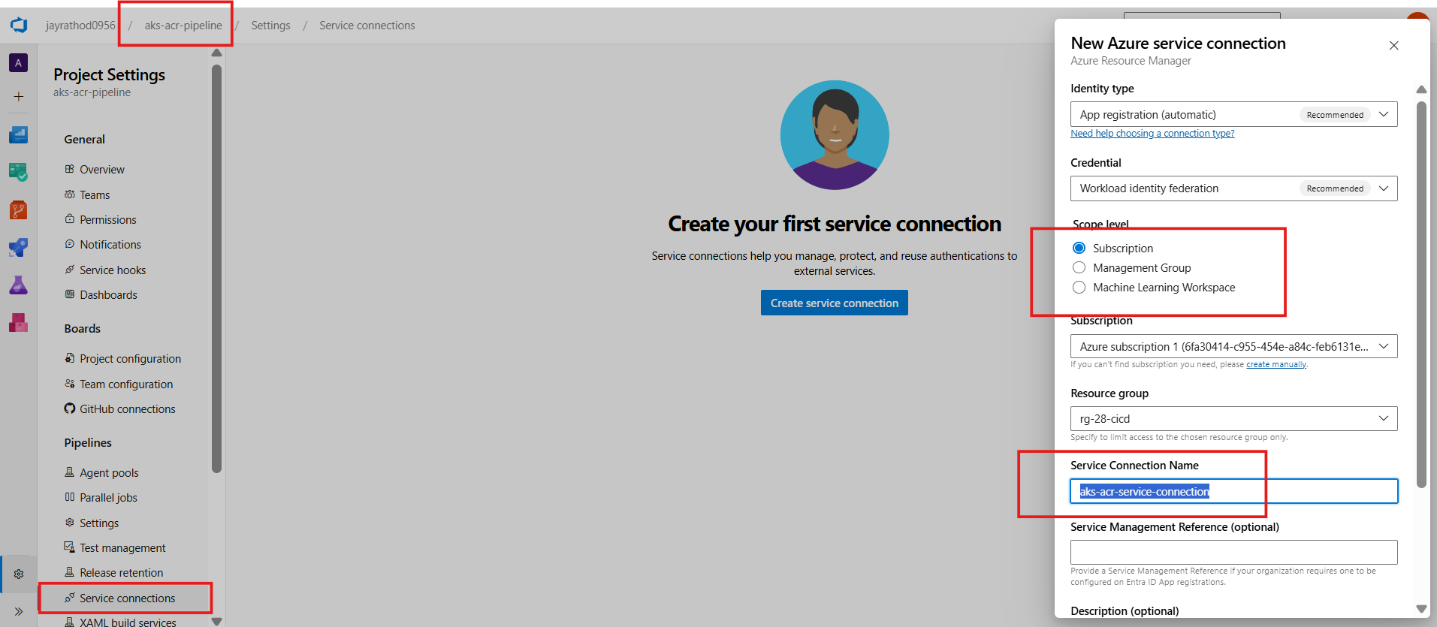
Verification from the resource group
Under role assignment
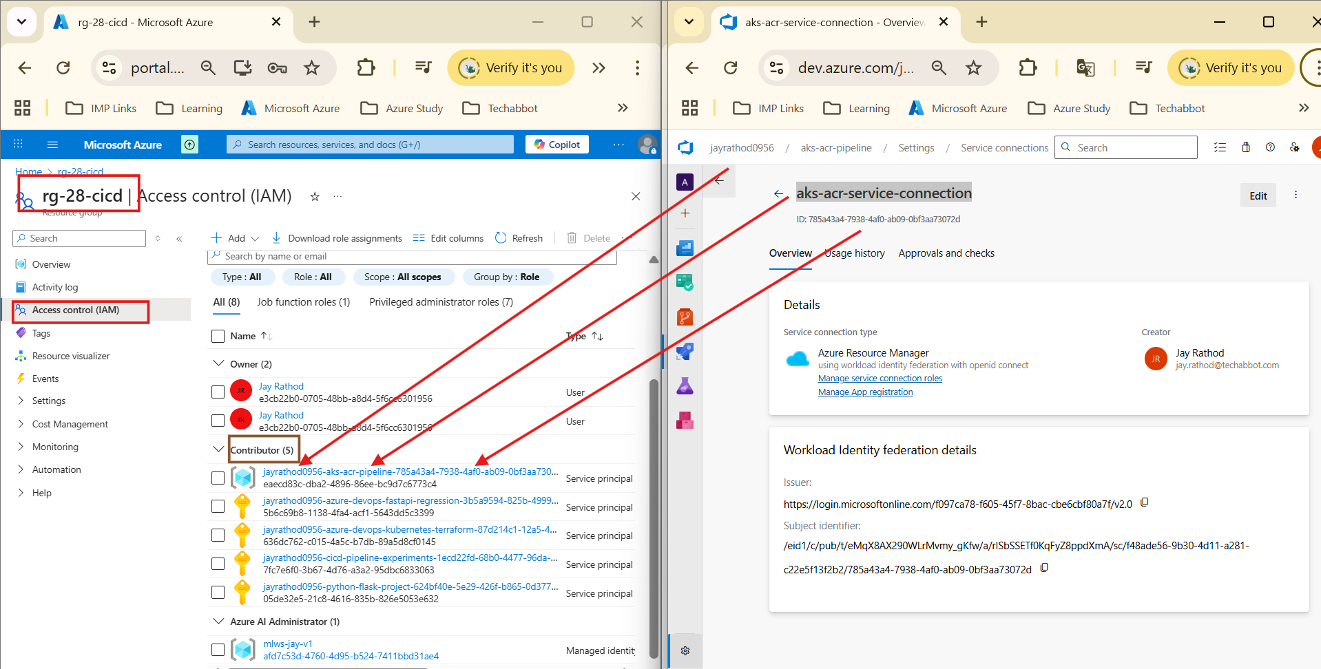

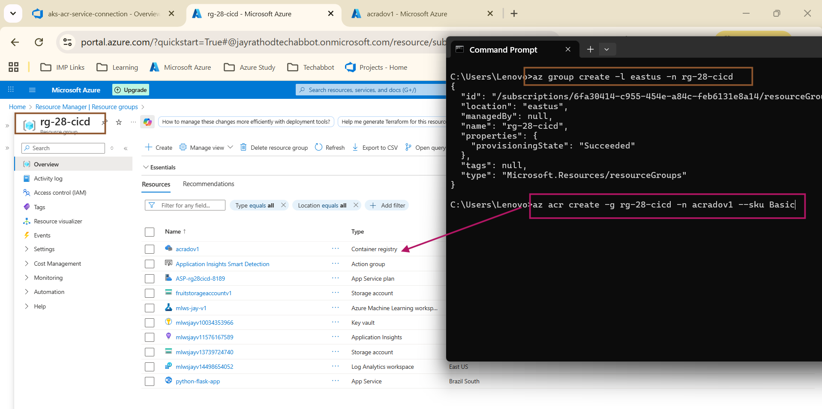
Create a resource group and container registry
az group create -l eastus -n rg-28-cicd
az acr create -g rg-28-cicd -n acradov1 --sku Basic

created Kubernetes services from UI
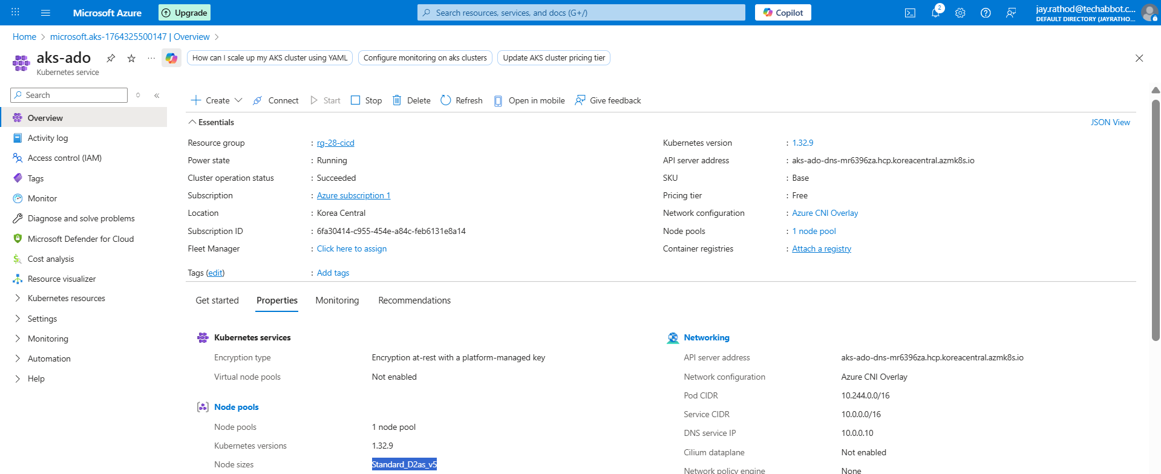
If by command we should attach with acr
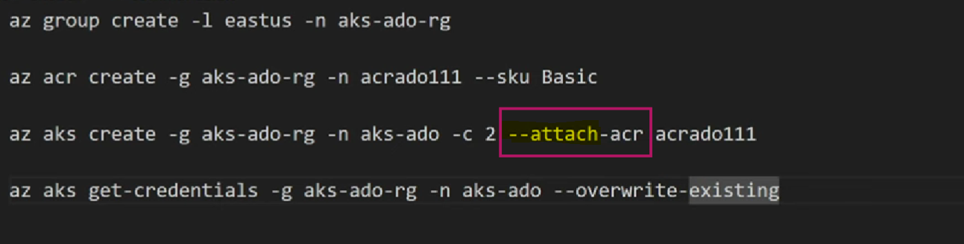

But from the UI if its missing we should attach from below
Else we need to explicitly provide in the pipeline
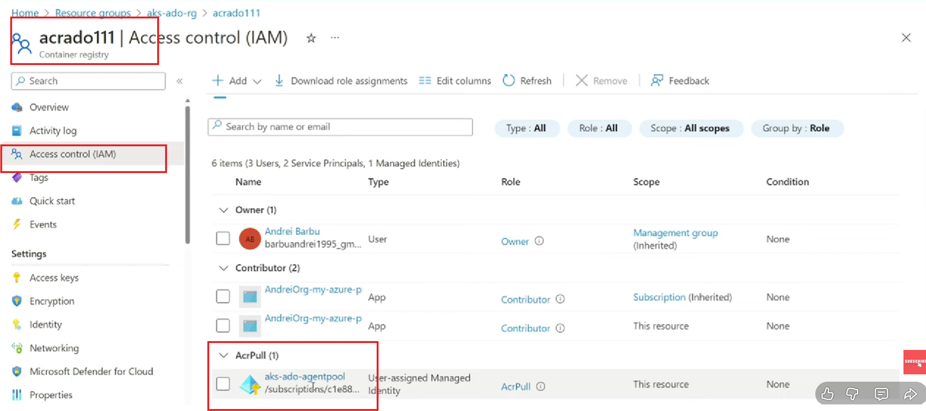

Create a pipeline

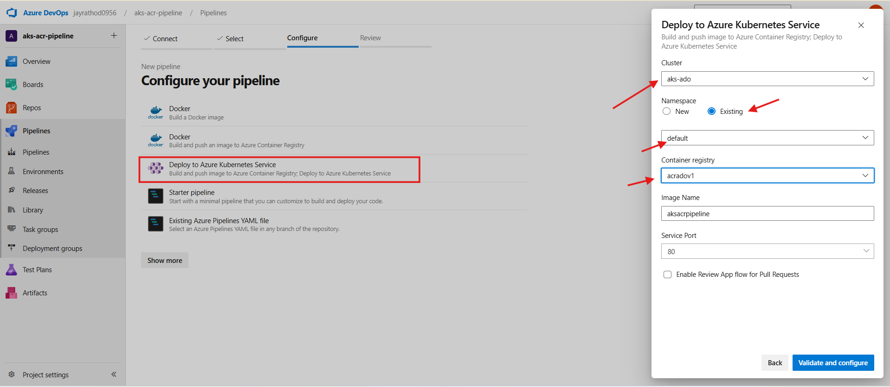

Before running pipeline check below
- Pool
- Running docker
Build script
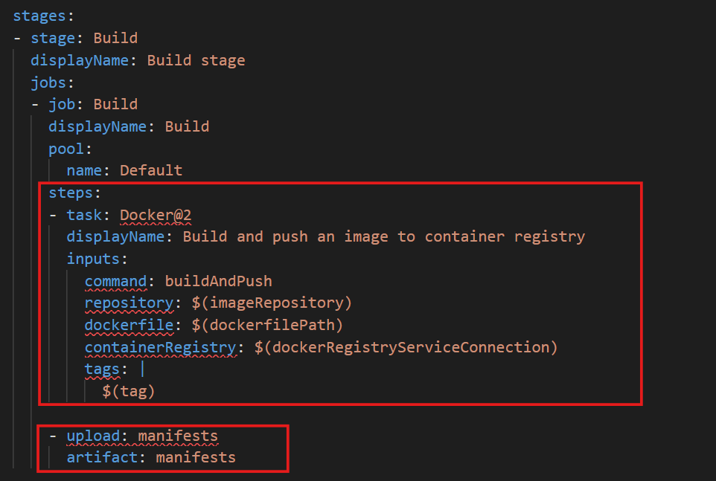
Verify the build
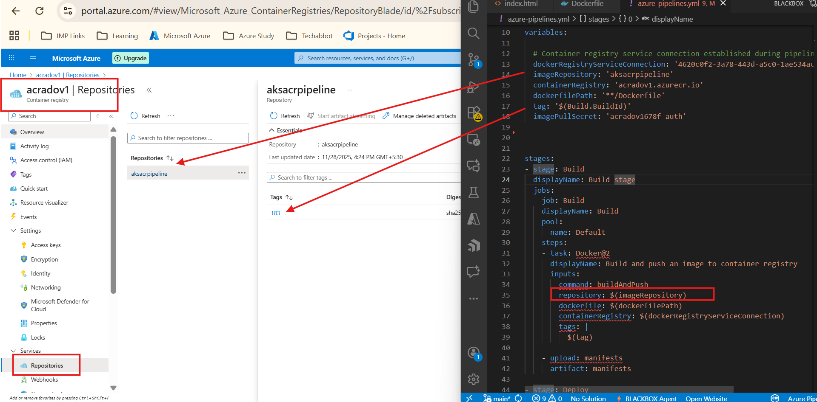

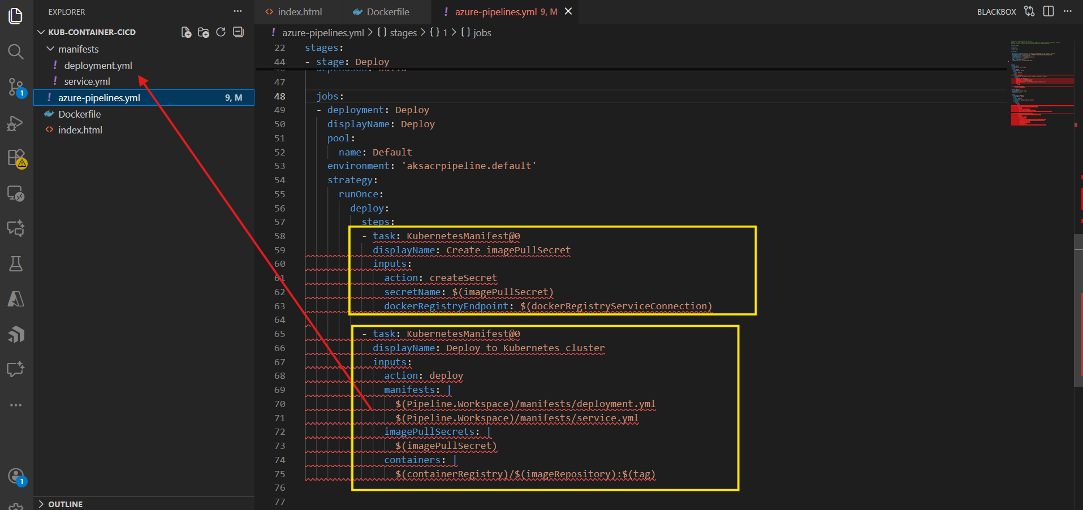

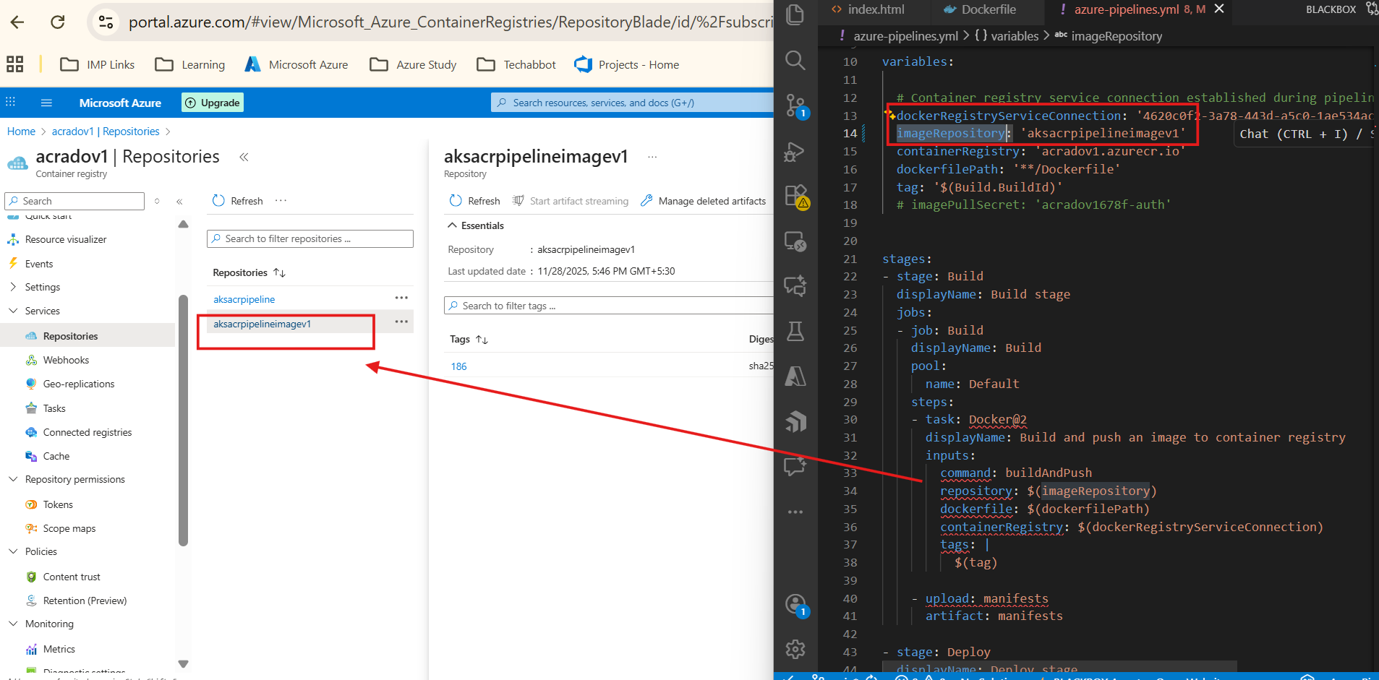

Verify the deployment from the local cli
Make a connection
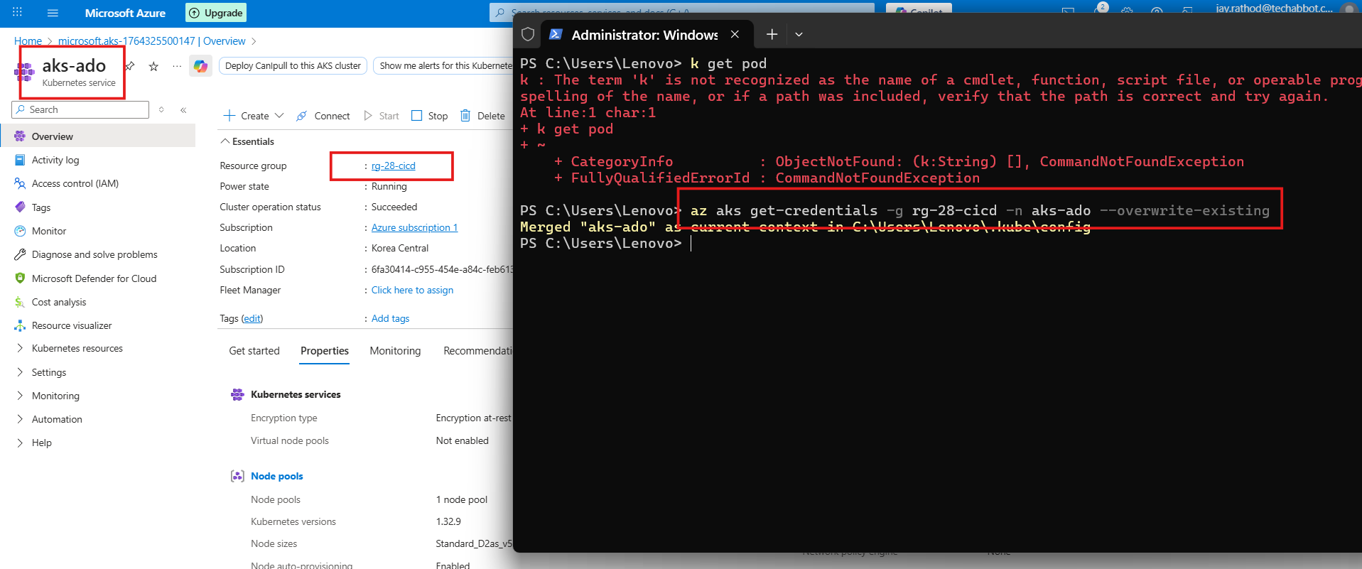

az aks get-credentials -g rg-28-cicd -n aks-ado --overwrite-existing

kubectl get pod,deploy,svc
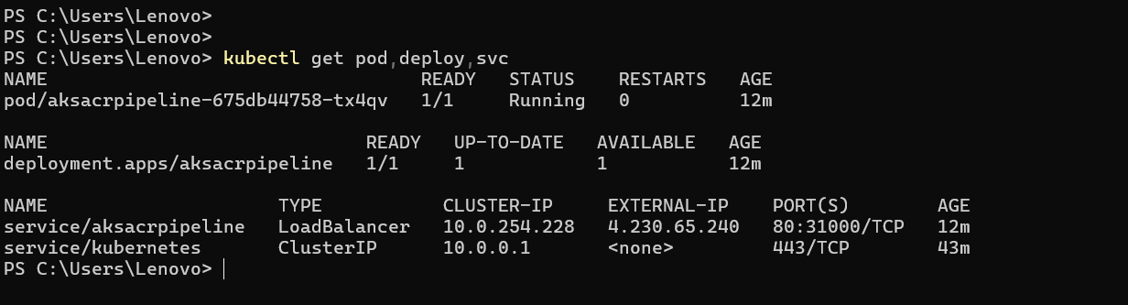

URL : 4.230.65.240
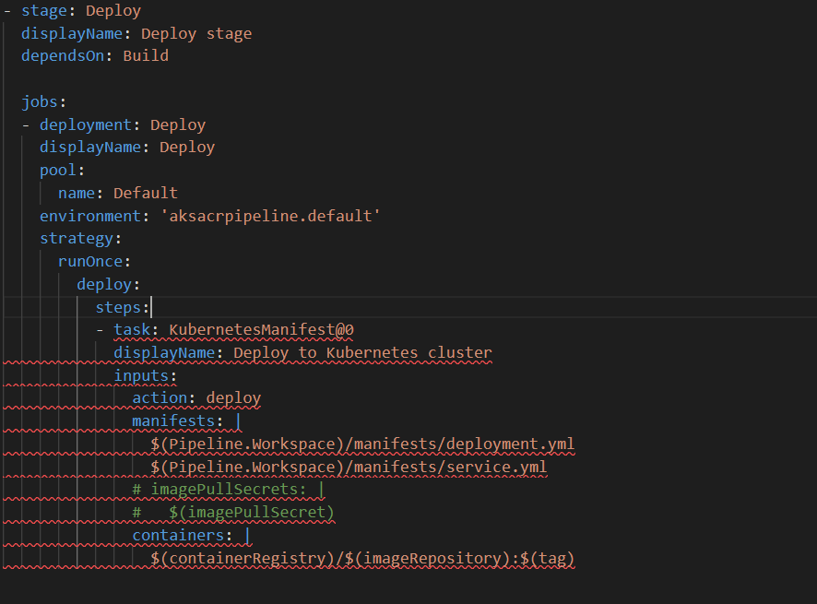
Only needed if we have added acrPull is added

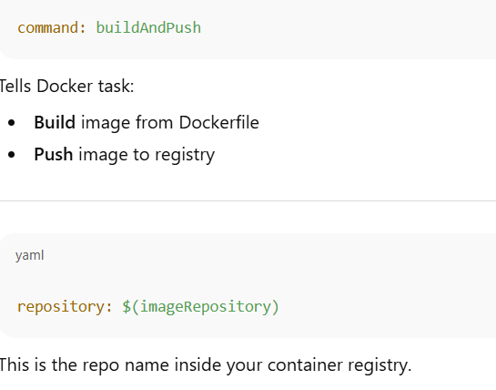
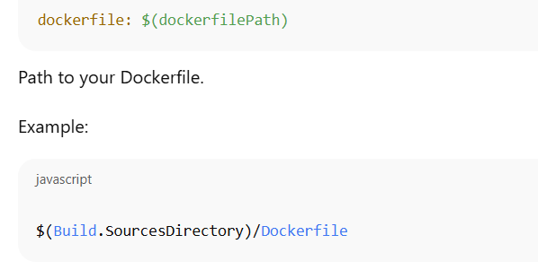
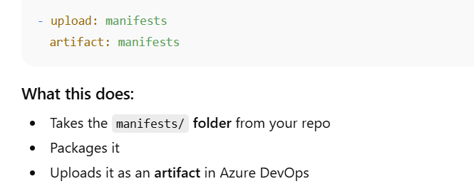
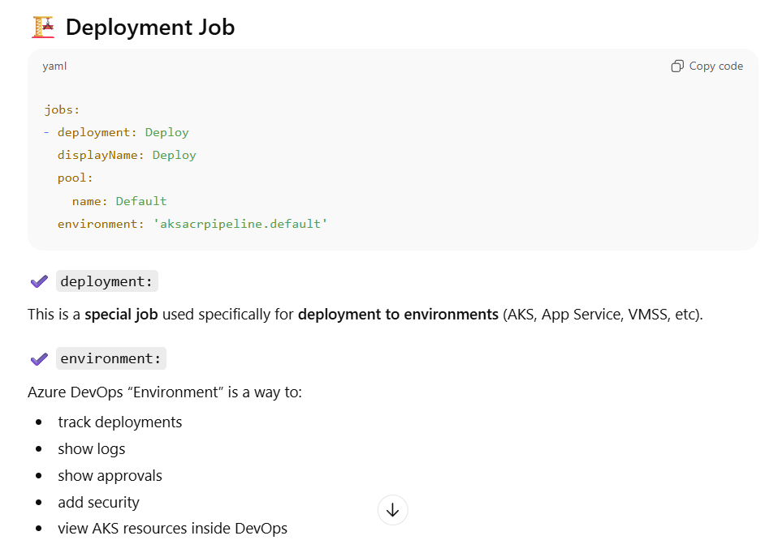
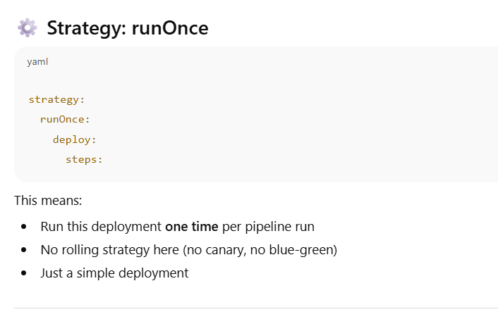
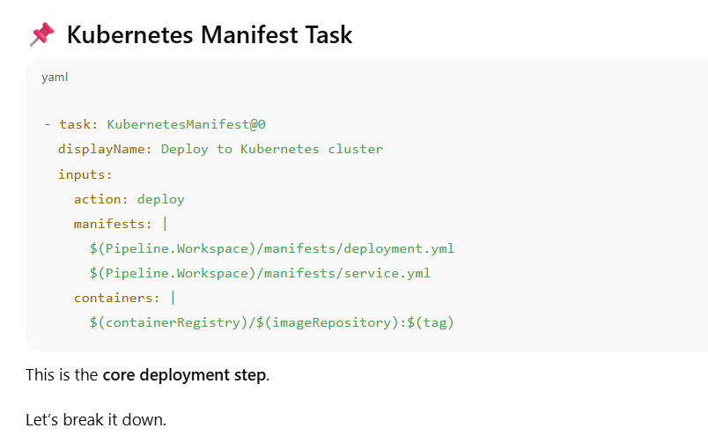
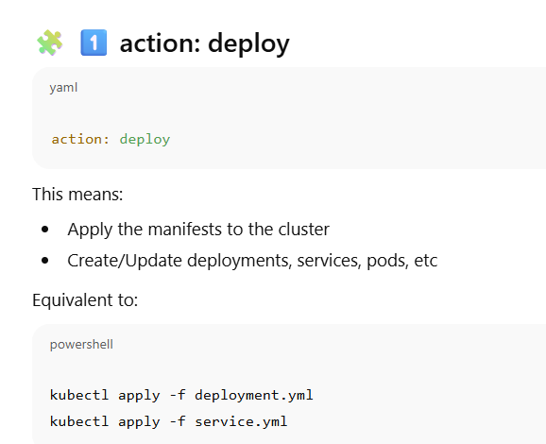
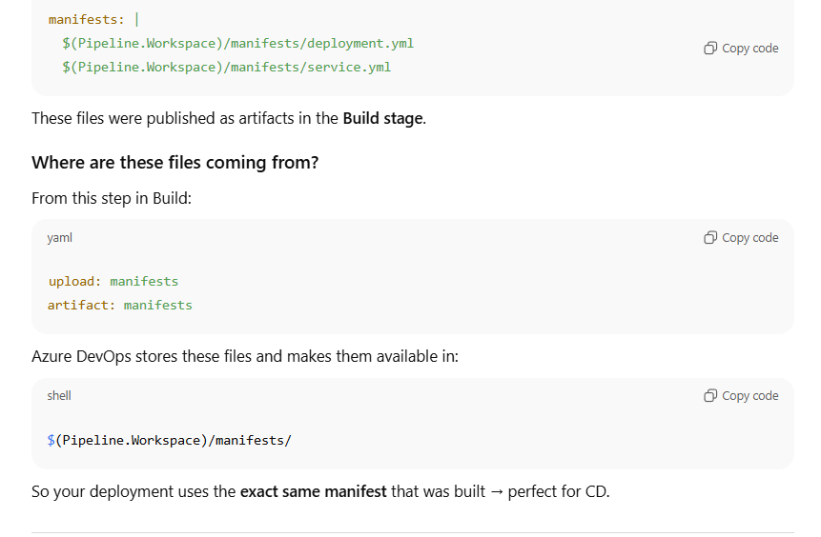
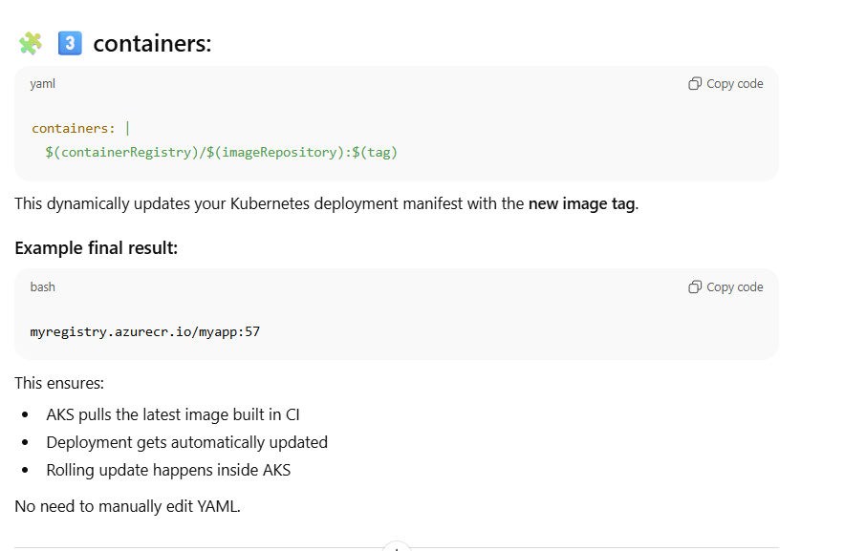
Part | Purpose
stage: Deploy | Deployment stage of pipeline
dependsOn: Build | Runs only if Build succeeds
deployment: Deploy | Special job type for deployments
environment: | Connects to AKS environment in DevOps
KubernetesManifest@0 | Task to deploy Kubernetes YAML
manifests: | Which YAML files to apply
containers: | Replaces container image and tag dynamically
action: deploy | Applies manifests (like kubectl apply)

